REVIEW OF BOĞAZIÇI UNIVERSITY'S GUIDELINES
FOR THE PREPARATION OF THESES AND DISSERTATIONS

YOUR FULL NAME AS REGISTERED

BOĞAZİÇİ UNIVERSITY
2025

A REVIEW OF BOĞAZIÇI UNIVERSITY'S GUIDELINES
FOR THE PREPARATION OF THESES AND DISSERTATIONS

Thesis submitted to the
Institute for Graduate Studies in Social Sciences
in partial fulfillment of the requirements for the degree of

Master of Arts or Doctor of Philosophy
in
Your Department

by
Your Full Name as Registered

Boğaziçi University
2025

A review of Boğaziçi University's Guidelines
for the Preparation of Theses and Dissertations

The thesis of Your Full Name as Registered
has been approved by:

Assoc. Prof. Karl Paul Polanyi _________________________
(Thesis Advisor)

Prof. Karl Heinrich Marx _________________________
(Thesis Co-Advisor)

Assoc. Prof. Max Weber _________________________

Assist. Prof Auguste Comte _________________________

Prof. Pierre Bourdieu _________________________
(External Member)

January 2025

DECLARATION OF ORIGINALITY

I, Your Full Name As Registered, certify that
- I am the sole author of this thesis and that I have fully acknowledged and documented in my thesis all sources of ideas and words, including digital resources, which have been produced or published by another person or institution;
- this thesis contains no material that has been submitted or accepted for a degree or diploma in any other educational institution;
- this is a true copy of the thesis approved by my advisor and thesis committee at Boğaziçi University, including final revisions required by them.

Signature……………………………………………...
Date…………………………………………...............

ABSTRACT
This is Only a Dummy Thesis Title, Not a Real One:
Capitalize Your Own Title in the Same Way

(İlk paragraflar girintili olmamalı, bu metin içeriğini okuyunuz ve kendi abstract içeriğinizi yazdıktan sonra siliniz. Taslak içerisinde kırmızı renkle belirtilmiş bölümleri kendi içeriğinize göre düzenleyiniz ve metin rengini siyah olarak değiştiriniz.) The abstract should consist of a brief, comprehensive summary of the contents of the thesis. The aim is to allow readers to survey the contents of the thesis quickly. It should mention the aim of your research, what you did and how you did it, and the results. It should also indicate the importance of the thesis—what makes it worth reading, or what it contributes to your field of study. Abstract length for the Boğaziçi University Institute for Graduate Studies in the Social Sciences is 250 words maximum, so the abstract should fit onto a single page. The name of the author does not appear on the abstract page. The Turkish version of the abstract (with the heading Özet) should reflect the content and approximate length of the English abstract. As shown above, the word “Abstract” is capitalized and centered above the title of the thesis. The text of the abstract itself is double-spaced. Note that the first line is not indented, but begins flush with the left margin. Normally, an abstract should be a single paragraph. If a second paragraph is essential, please indent the second paragraph, maintaining double spacing throughout

ÖZET
Title Case Olarak Yazılmış Türkçe Tez Başlığı
Maksimum 15 Kelime Olmalı

(İlk paragraflar girintili olmamalı.) The Turkish version of the abstract (with the heading Özet) should reflect the content and approximate length of the English abstract. Türkçe özet sayfasından sonra doktora öğrencileri CV eklemeli. Samples bölümünden ilgili örneği dikkate alarak Curriculum vitae (CV) hazırlayınız. (CV PhD candidates only). https://sbe.bogazici.edu.tr/style-guide-theses To facilitate the preparation of graduate theses in accordance with the format specified in the guide, you may use the thesis template—prepared with the required pages and key elements—as a basis and adapt its content to your own work. However, it is the student's responsibility to carefully review the thesis guide and ensure that the thesis complies with all formatting requirements. Please remember that you are expected to review the entire guide thoroughly.

ACKNOWLEDGMENTS

ACKNOWLEDGMENTS is optional. An acknowledgments page can be used to recognize those who have provided special guidance or support during your research. Be sure to acknowledge all organizations that have provided financial support. Acknowledgments should be expressed simply, preferably on a single page, double-spaced. Title should be Acknowledgments not Acknowledgements.

DEDICATION

DEDICATION is optional. A dedication page is a short tribute to a special person or group. Many students use the heading “DEDICATION”, but a page heading is optional.

or Italics may be used for the dedication statement, if desired.
Please center it on the page.

TABLE OF CONTENTS

Please refer to the link below for how the table of contents should look.
https://sbe.bogazici.edu.tr/sites/bsbe.bogazici.edu.tr/files/s11_table_of_contents.pdf
Please note that main headings are expressed in capital letters.
For example:
CHAPTER 1: INTRODUCTION
CHAPTER 2: LITERATURE REVIEW
2.1 Technology integration in the general picture
2.2 The barriers on the track of the technology integration process
CHAPTER 3: METHODOLOGY
3.1 Research design
3.2 Participants
3.3 Instrumentation
APPENDIX A: ETHICAL APPROVAL
APPENDIX B: INTERVIEW QUESTIONS
REFERENCES
Starting with the first chapter, all chapters of the main text and all sections of the back matter (references and any appendices) are included in the table of contents.
What to include: Only main headings (e.g. chapters, appendices, references, etc.) and first-level chapter sub-headings should be shown in the table of contents. No sub-headings beyond first-level sub-headings are allowed in the table of contents.
All elements must appear exactly as they appear in the main text.
Page numbers in the table of contents must reflect the actual pages in the text and must be precisely aligned with the right margin.
There is : after the main headings in the Table of Content, but it is not in the text.

Sub-headings must use sentence-case case (i.e. only the first word and proper nouns are capitalized).
If there is a sub-title, the first letter of the first word of the sub-title is capitalized.
Example: Warner’s mass public subject: Identification or alienation?
Put no period at the end of a sub-heading title.
After the number of each sub-heading designation, put two horizontal spaces (hit the space bar twice) before the text of the sub-heading starts.

LIST OF TABLES

Table 1. Tables Are Listed in the Order They Appear in the Manuscript.................67
Table 2. All Major Words Are Capitalized in the Titles of Tables............................74
Table 3. Here is an Example of How a Title Should Look if it Extends Beyond a
Single Line..................................................................................................................78
Table 4. Use a Period, Not a Colon, After the Table Number...................................87
Table 5. Put Two Spaces after the Table Number, Before the Title Begins.............90
Table 6. The List of Tables is Needed Only If the Thesis Contains 5 or More.........99

LIST OF FIGURES

Figure 1. Figures are listed in the order they appear in the manuscript.....................49
Figure 2. Only the first word in the figure title is capitalized....................................62
Figure 3. Use a period, not a colon after the figure number......................................83
Figure 4. Only if 5 or more figures in the thesis........................................................88
Figure 5. Put two spaces after the figure number, before the caption begins............93

CHAPTER 1
INTRODUCTION

Indenting paragraphs: Paragraphs must be uniformly indented, approximately 1.25–1.50 cm (Microsoft Word uses 1.27cm as the default value). Do not indent manually by repeatedly hitting the space bar.
Exceptions: Do not indent the first paragraph of a chapter, the first paragraph of a chapter sub-section, or the continuation of an existing paragraph immediately following a block quote, table or figure.
This outline has been prepared to assist you in this process. Please remember that it is your responsibility to review the guide and ensure that your thesis is formatted accordingly.

1.1 First-level sub-heading example
Sub-headings are preceded by two double-spaces. There is only the usual (i.e. one) double-space between the sub-heading and the first line of the text. Note that there are two spaces following the number (1.1) and the first level of the sub-heading.
The second paragraph and the following paragraphs should be indented. Pagination: The font should be Times New Roman size 12. Numerals: Use Roman numerals for the front matter, Arabic numerals for the main text. Front matter: Use lower-case Roman numerals (e.g. i, ii, iii . . . ). The first visible page number must be page iv, on the abstract page (page v for Turkish Language and Literature). The cover page is not counted as a page in the context of the thesis. Pagination starts with the title page and continues to the last page of the thesis. The title page is counted in the pagination, but its page number is “hidden,” that is, it does not appear on the page.

1.1.1 Second-level sub-heading example
The second-level sub-heading, like the first-level ones, are preceded by two double spaces. Similarly, there is only one double-space between the sub-heading and the first line of the text. Remember to put two spaces after the number.
The second paragraph and the following paragraphs should be indented. Please note that you must leave space before subheadings. Please check the relevant example. https://sbe.bogazici.edu.tr/sites/bsbe.bogazici.edu.tr/files/s4_chapter_heading_sub_headings.pdf
The main heading settings and the space that should be left after it should be like this.
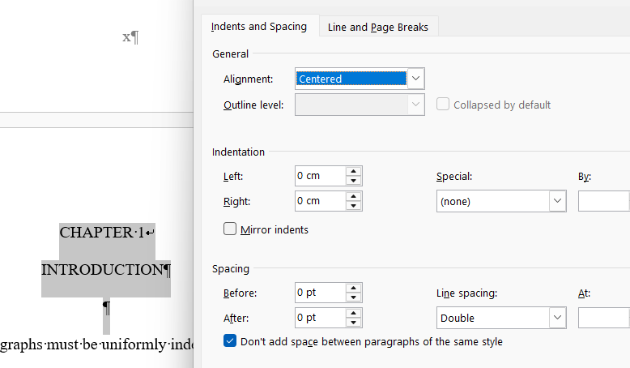

APPENDIX

APPENDIX TITLE

Why use an appendix? Appendices are used for materials that support the main text, including data sheets or tables that are too big to put in the main text, original passages of translated text used in the main text, maps, technical figures, interview transcripts, scans of original documents and so on.
Each appendix must be referred to in the main text. Each appendix must start at the top of a new page. Each appendix must have its own designation (e.g. Appendix A, Appendix B) and its own title. If there is a single appendix, the designation is simply “APPENDIX” (not APPENDIX A). Tip: These page headings should be formatted just like the chapter headings.

REFERENCES

The required style guide for references and in-text citations is the APA 7th edition.
Hanging indent (for References)
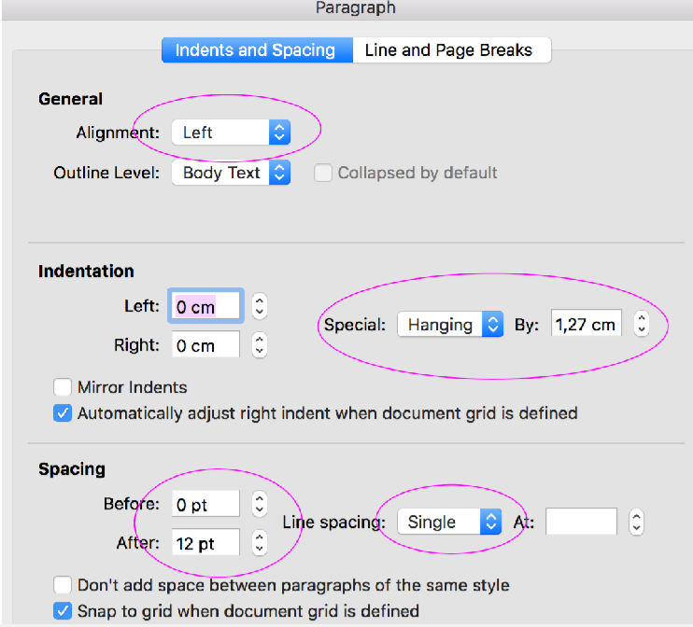
URLs: All URLs in the reference list must be unlinked (as in the rest of the thesis).

